Copy S3 object from one bucket to another bucket using Lambda function

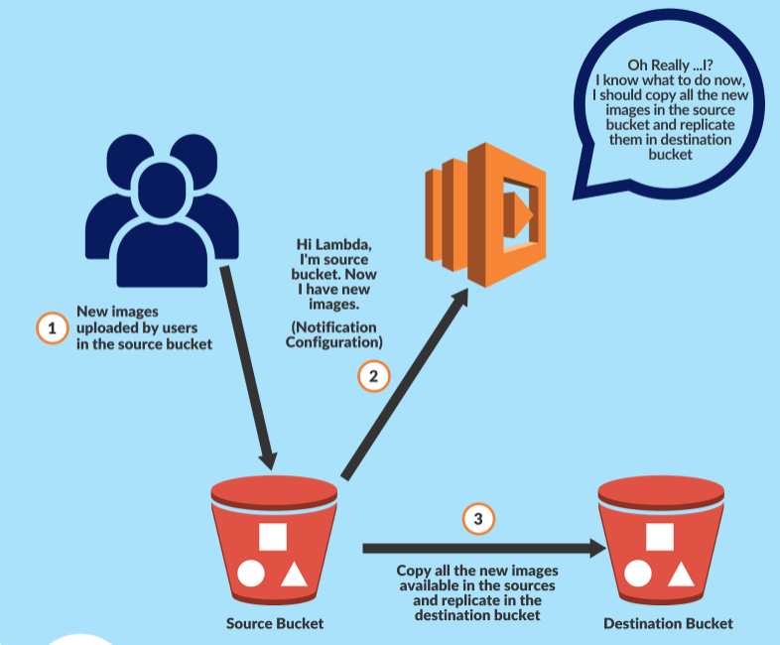

Create two buckets

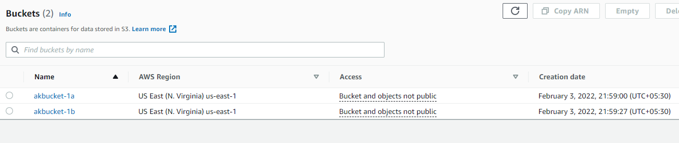

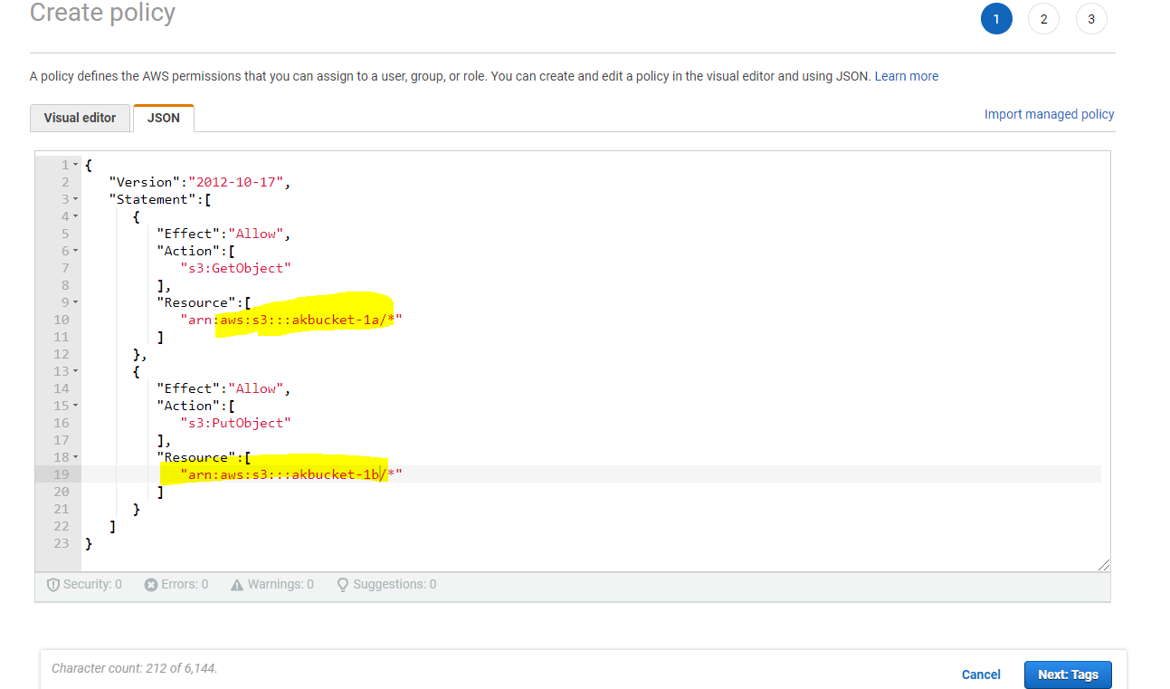

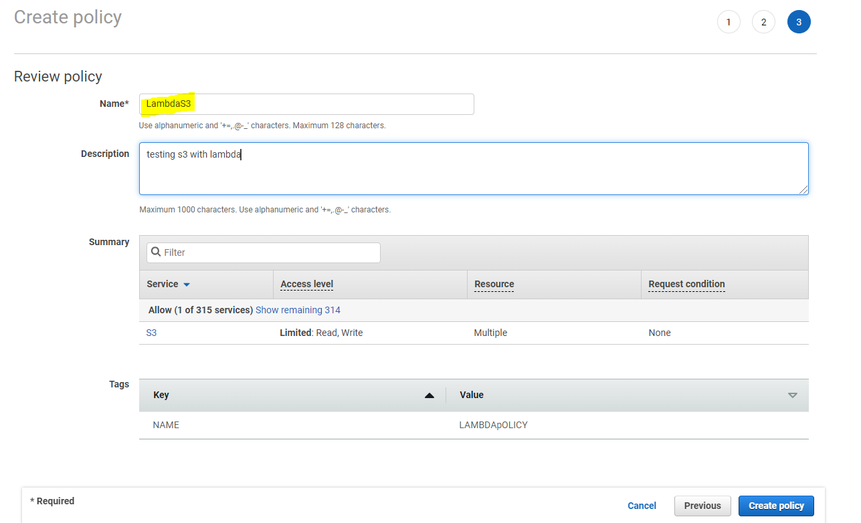

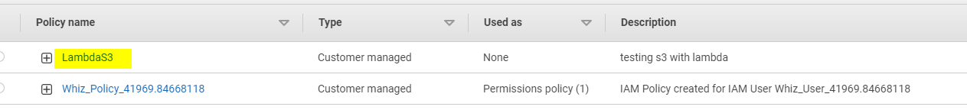

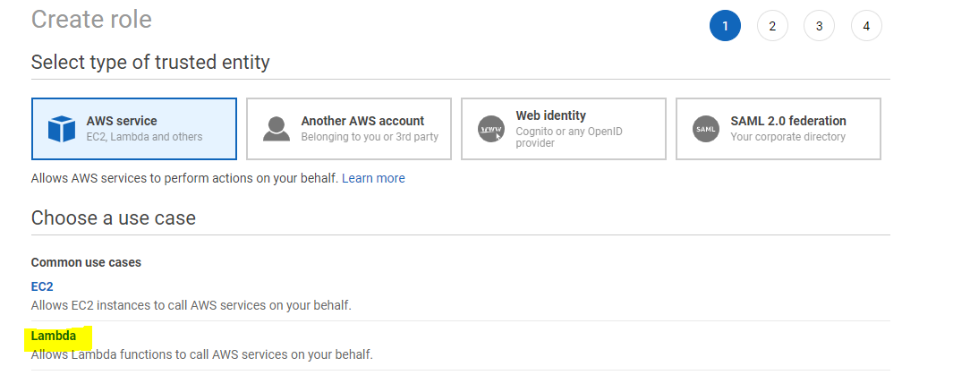

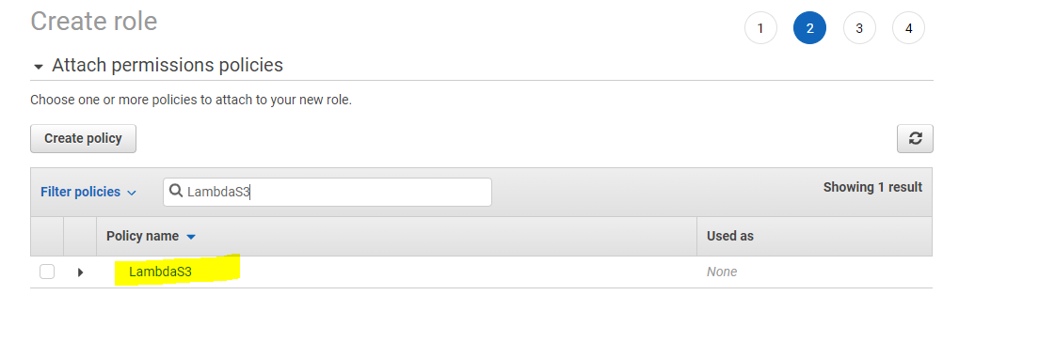

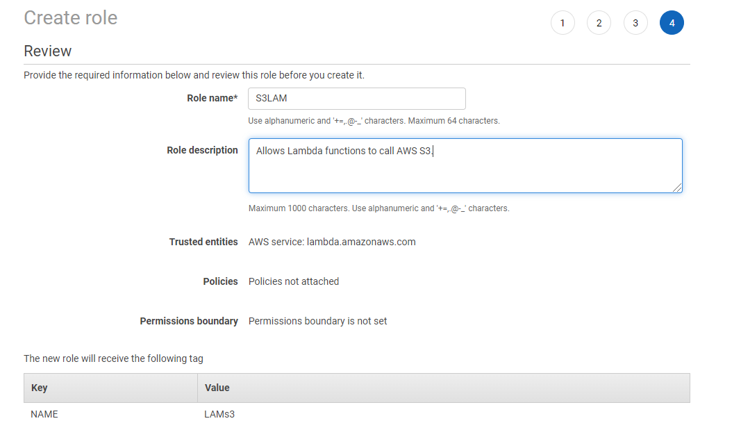

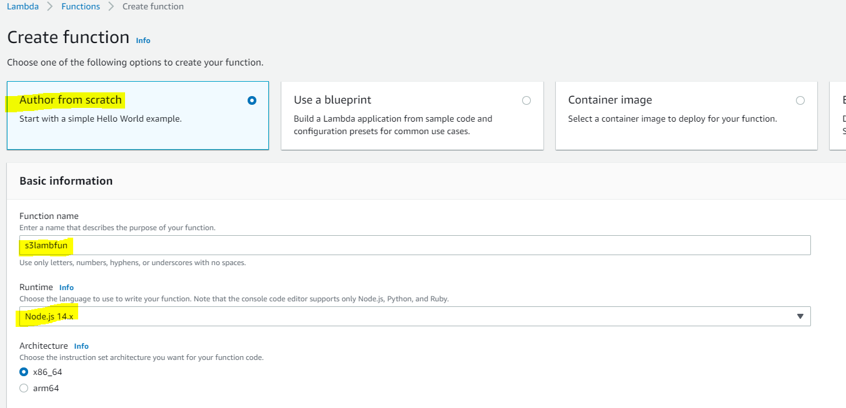

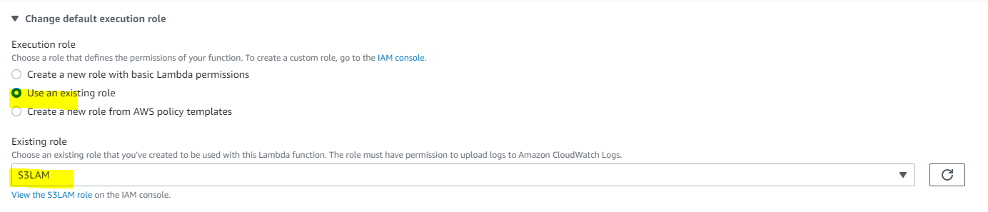

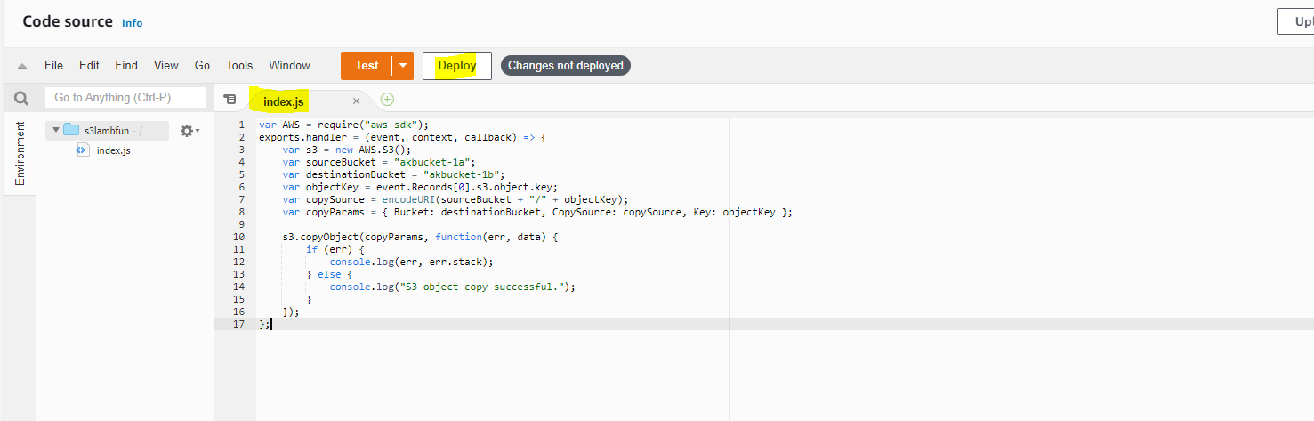

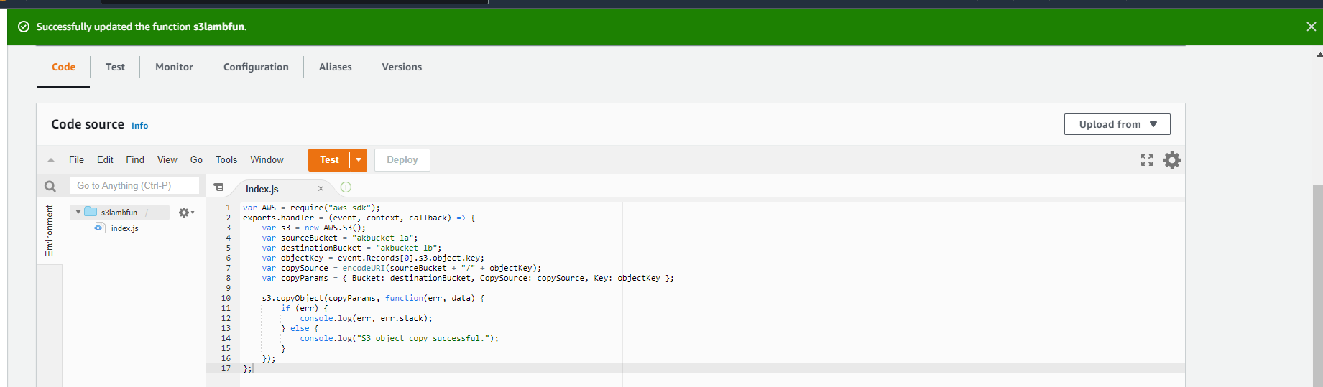

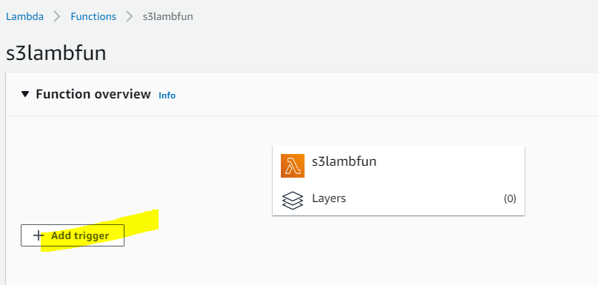

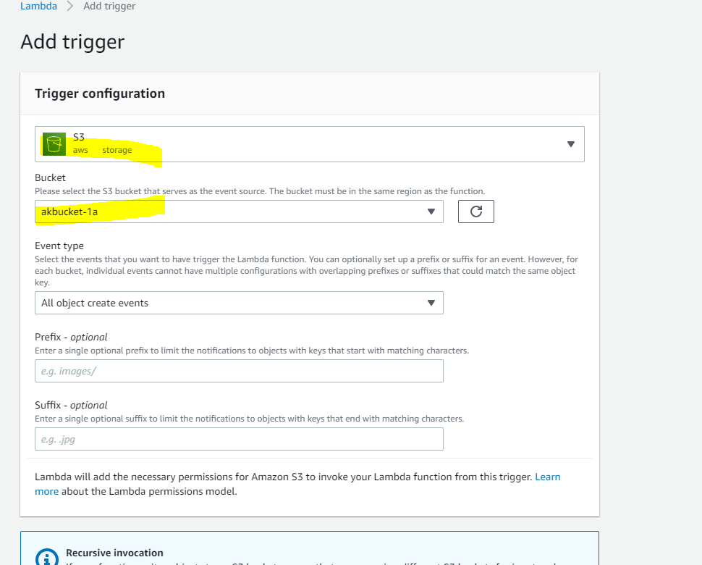

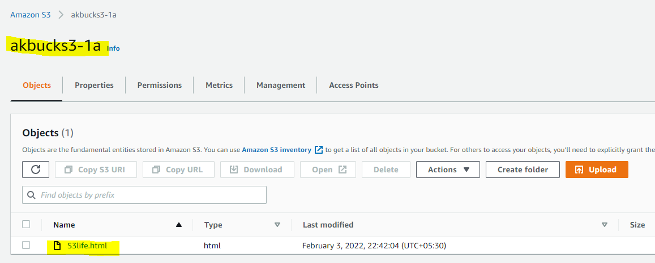

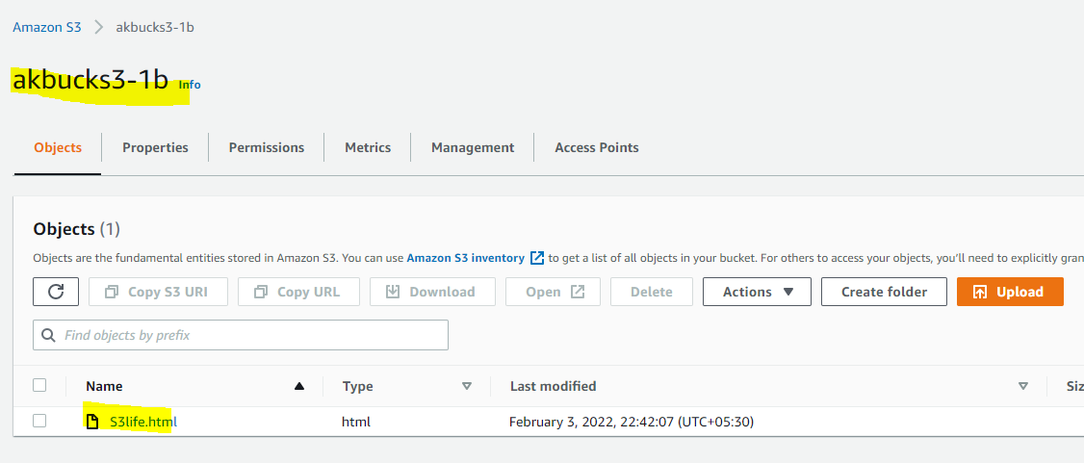

Lambda function

**var AWS = require("aws-sdk");  
exports.handler = (event, context, callback) => {  
    var s3 = new AWS.S3();  
    var sourceBucket = "**mysourcebucket12345**";  
    var destinationBucket = "**mydestinationbucket12345**";  
    var objectKey = event.Records[0].s3.object.key;  
    var copySource = encodeURI(sourceBucket + "/" + objectKey);  
    var copyParams = { Bucket: destinationBucket, CopySource: copySource, Key: objectKey };  
      
    s3.copyObject(copyParams, function(err, data) {  
        if (err) {  
            console.log(err, err.stack);  
        } else {  
            console.log("S3 object copy successful.");  
        }  
    });  
};**

**IAM policy**

**{   
   "Version":"2012-10-17",  
   "Statement":[   
      {   
         "Effect":"Allow",  
         "Action":[   
            "s3:GetObject"  
         ],  
         "Resource":[   
            "**arn:aws:s3:::mysourcebucket12345**/*"  
         ]  
      },  
      {   
         "Effect":"Allow",  
         "Action":[   
            "s3:PutObject"  
         ],  
         "Resource":[   
            "**arn:aws:s3:::mydestinationbucket12345**/*"  
         ]  
      }  
   ]  
}**